plot(oltemp$Total.Logins...EngradePro...ConnectED ~oltemp$dateconverted )

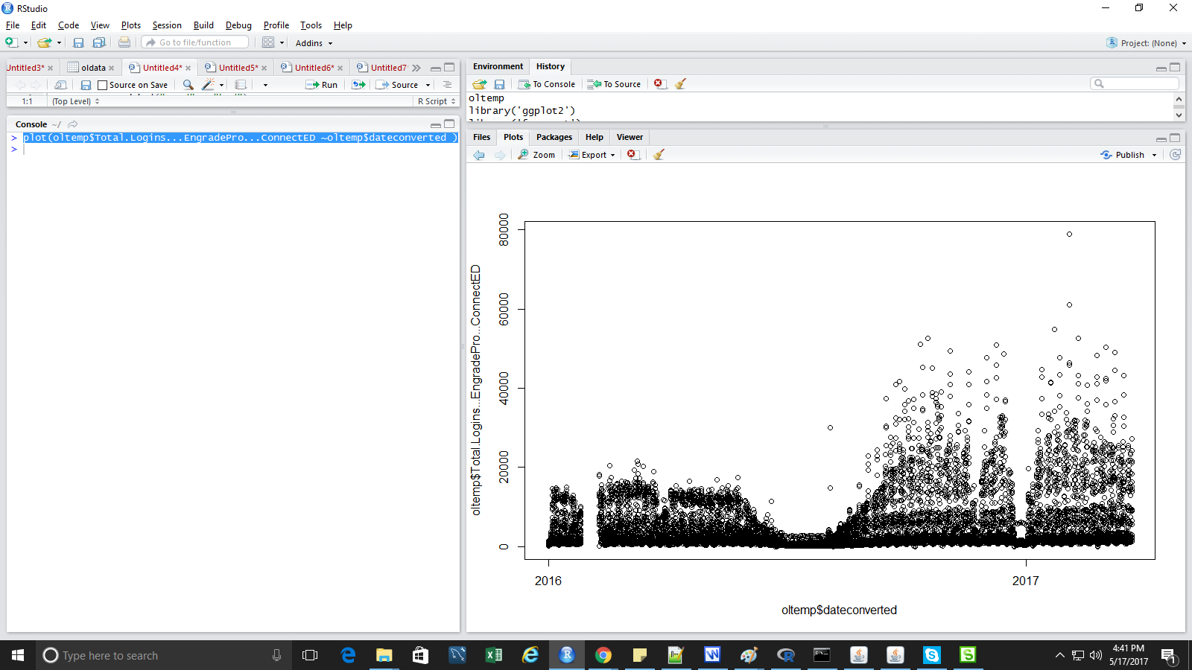

ggplot(oltemp, aes(dateconverted, Total.Logins...EngradePro...ConnectED)) +
+ geom_line() + scale_x_date('Date') + ylab("login counts")

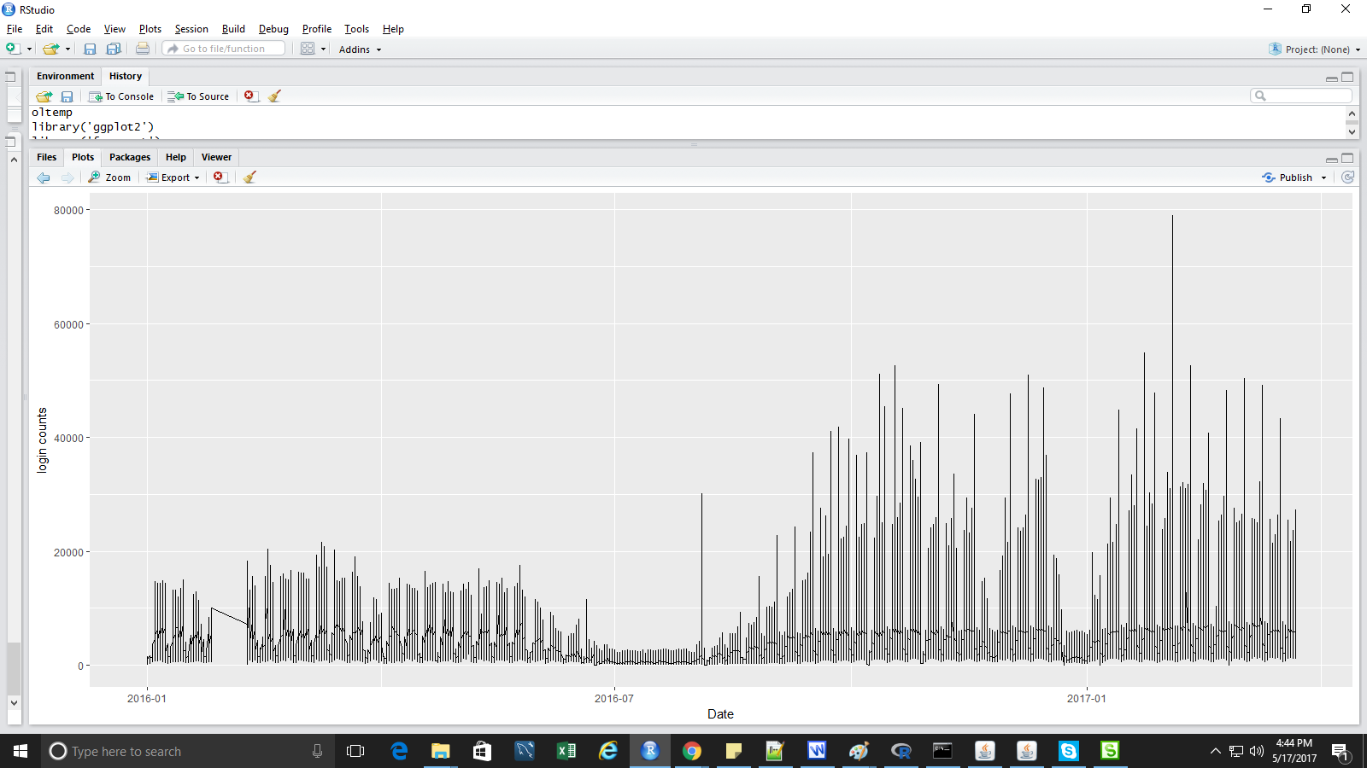

oltempdate$cleants = tsclean(lat_ts)

length(oltempdate$cleants)

ggplot(oltempdate, aes(dateconverted,cleants)) + geom_line() + scale_x_date('month') + ylab("logins") +
xlab("")

oltempdate$cnt_ma = ma(oltempdate$cleants, order=24) # using the clean count with no outliers
oltempdate$cnt_ma30 = ma(oltempdate$cleants, order=720)

ggplot() +
geom_line(data = oltempdate, aes(x = dateconverted, y = cleants, colour = "Counts")) +
geom_line(data = oltempdate, aes(x = dateconverted, y = cnt_ma, colour = "hourly")) +
geom_line(data = oltempdate, aes(x = dateconverted, y = cnt_ma30, colour = "monthly")) +
ylab('login Count')

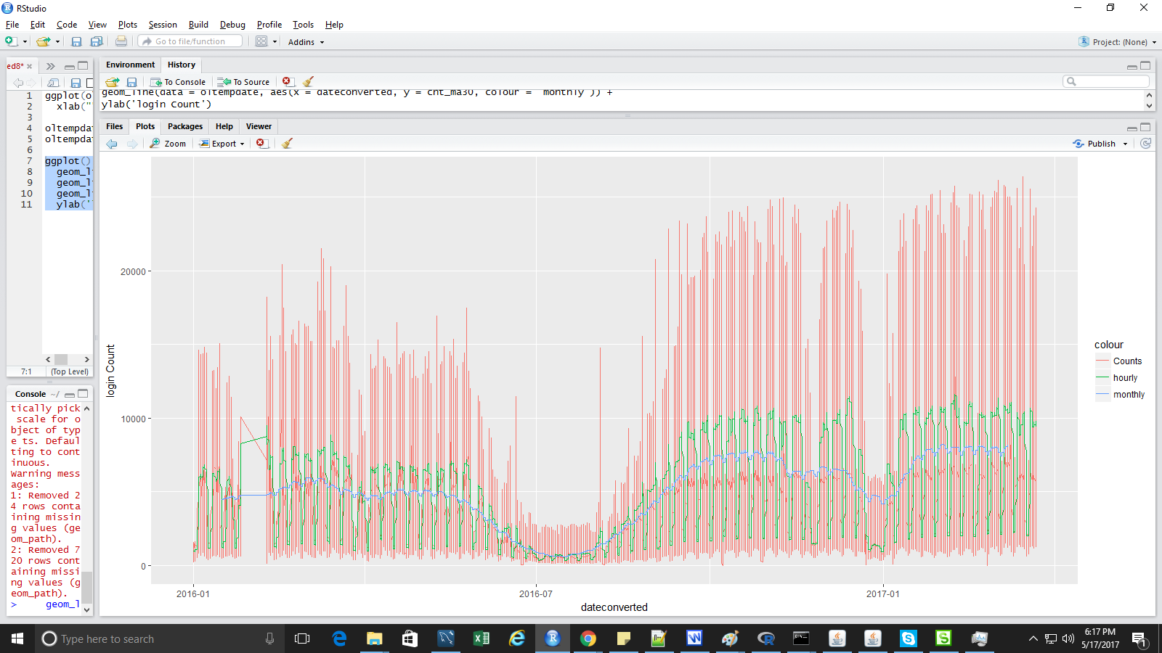

ggplot() +
geom_line(data = oltempdate, aes(x = dateconverted, y = cleants, colour = "Counts")) +
geom_line(data = oltempdate, aes(x = dateconverted, y = cnt_ma, colour = "hourly")) +
geom_line(data = oltempdate, aes(x = dateconverted, y = cnt_ma30, colour = "monthly")) +
ylab('login Count')

count_ma = ts(na.omit(oltempdate$cnt_ma), frequency=168)# week
decomp = stl(count_ma, s.window="periodic")
deseasonal_cnt <- seasadj(decomp)
plot(decomp)

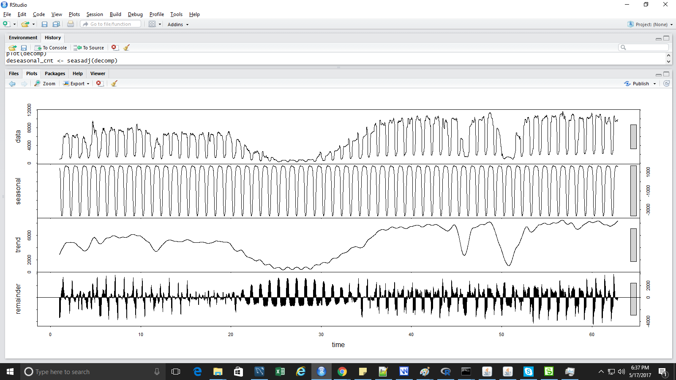

Additive or multiplicative

We can series is stationary
ADF test to find out stationay

Find the arima paramemeters

Acf - ma(q)
PACF - AR(p)
Difference - d
ARIMA(p,d,q)

ACF

